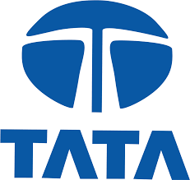 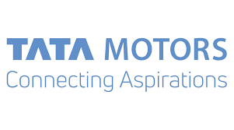

**BUSINESS VALUATION PROJECT REPORT**

## TABLE OF CONTENTS

|  |  |  |
| --- | --- | --- |
| **S.NO** | **TITLE** | **PAGE.NO** |
| 1 | Introduction to Indian Automobile Industry | 2 |
| 2 | Market Size & Sector Composition | 3 |
| 3 | Company: TATA Motors Ltd. | 3 |
| 4 | Variables used for performing Economic Analysis: GDP, Inflation | 4 |
| 5 | Variables used for performing Economic Analysis: Unemployment, FDI | 5 |
| 6 | Variables used for performing Industry Analysis: Segmentation, Key Players | 6 |
| 7 | Variables used for performing Industry Analysis: Porters 5 Forces Model, SWOT Analysis | 7 |
| 8 | Variables used for performing Company Analysis: Company Overview, Business model | 8 |
| 9 | Variables used for performing Company Analysis: Shareholding patterns, Growth drivers | 9 |
| 10 | Variables used for performing Company Analysis: Capital structure, Dividend History, Interest Coverage Ratio, DuPont Analysis | 10 |
| 11 | Bibliography | 11 |

**TATA MOTORS ANALYSIS**

**INTRODUCTION TO INDIAN AUTOMOBILE INDUSTRY**

The Indian auto industry became the 4th largest in the world with sales increasing 9.5 per cent year-on-year to 4.02 million units (excluding two wheelers) in 2017. It was the 7th largest manufacturer of commercial vehicles in 2018.

The Two Wheelers segment dominates the market in terms of volume owing to a growing middle class and a young population. Moreover, the growing interest of the companies in exploring the rural markets further aided the growth of the sector.

India is also a prominent auto exporter and has strong export growth expectations for the near future. Automobile exports grew 14.5 per cent during FY 2019. It is expected to grow at a CAGR of 3.05 per cent during 2016-2026. In addition, several initiatives by the Government of India and the major automobile players in the Indian market are expected to make India a leader in the two-wheeler and four-wheeler market in the world by 2020.

The government aims to develop India as a global manufacturing as well as a research and development (R&D) hub. It has set up National Automotive Testing and R&D Infrastructure Project (NATRiP) centers as well as a National Automotive Board to act as facilitator between the government and the industry. Under (NATRIP), five testing and research centers have been established in the country since 2015.

The Indian government has also set up an ambitious target of having only electric vehicles being sold in the country. Indian auto industry is expected to see 8-12 per cent increase in its hiring during FY19.

Automobile exports grew 14.50 per cent in FY19. It is expected to grow at a CAGR of 3.05 per cent during 2016-2026. Domestic two-wheeler industry is expected to grow at 8-10 per cent during FY19. Also, Luxury car market in India is expected to grow at a 25 per cent CAGR till 2020. The Government of India expects automobile sector to attract US$ 8-10 billion in local and foreign investments by 2023.

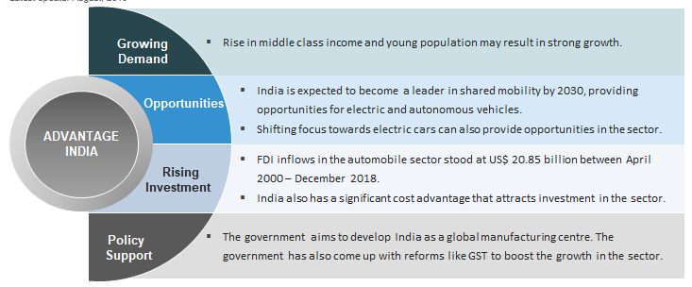

**MARKET SIZE AND SECTOR COMPOSITION**

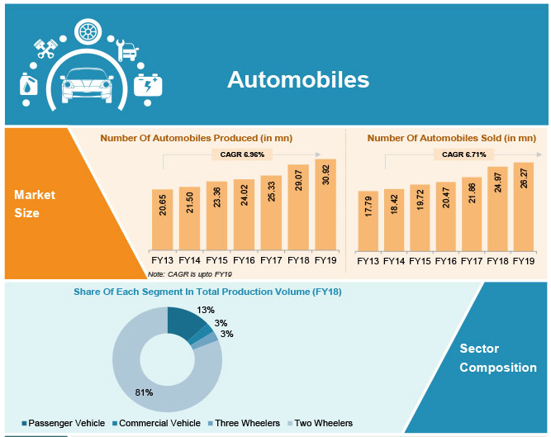

**TATA MOTORS:**

Tata Motors was established in 1945 under the Tata Group. It is among the world’s leading manufacturers of automobiles with around 81,090 employee strength. It was the market leader in commercial vehicles segment with about 44 per cent market share in FY18. It is present in segments like cars and utility vehicles, trucks and buses, and Defense. The company has extended its presence internationally through entering into joint ventures (JV) like the strategic alliance with Fiat and Marcopolo. Tata Motors is present in about 175 countries with research and development (R&D) centers in UK, Italy, India and South Korea.

|  |  |
| --- | --- |
| 2018 | Tata Motors created a separate vertical for electrical vehicles to tap into the market potential. |
| 2017 | Introduced a sum brand – TAMO |

**VARIABLES USED FOR PERFORMING ECONOMIC ANALYSIS:**

1. GDP
2. Inflation
3. Unemployment
4. Foreign direct Investment
5. **GDP:**

In the above GDP graph, we can see that the GDP Growth has declined and the slowdown in the economy have also impacted the automobile Industry.

Tata Motors total revenue Growth have shown extreme patterns, the growth has become negative in 2019 because of various challenges like

* Ongoing credit crunch
* Low consumer spending
* Transition to BSVI emission norms
* The sales from China also declined by 34.1% (External factor) because of continued trade tensions and market uncertainty, manufacturing sectors have begun shedding jobs
* High cash outflows because of high fixed cost structure, dealer network profitability and high investments.

1. **INFLATION:**

* The Indian automotive industry is affected substantially by the general economic conditions in India and around the world. The demand for automobiles in the Indian market is influenced by factors including the growth rate of the Indian economy, easy availability of credit, and increase in disposable income among Indian consumers, interest rates, freight rates and fuel prices. Demand for automobiles, particularly passenger vehicles and commercial vehicles were adversely impacted.
* Interest rates remained firm thus making it difficult to purchase consumer durable items on finance. High costs of borrowing and elevated consumer price inflation adversely affected household consumer sentiment and spending. On the other hand, slowdown in GDP growth has been due to decline in both consumption and investment growth. Investments were stalled because of high interest rates, poor demand conditions, and regulatory issues.

1. **UNEMPLOYMENT:**

* The unemployment rate has increased from 3.6% in 2017 to 6.1 % in 2018. Because of high unemployment, consumer demands for automobile industry have fallen. Tata Motors had to face continuous shutdowns in recent past.
* Slumping sales of cars and motorcycles are leading to cut in factory days and landing off so many people unemployed. At an average, around 350,000 workers have been rendered off their jobs since April 2019, directly and indirectly related to automobile industries.
* The automobile sector contributes 7% to the Indian GDP and employs more than 35 million people directly and indirectly, accounting for nearly half of India’s manufacturing output. In the same sector, the rate of jobless-ness has rose up to 7.51% in July 2019 from 5.66% a year earlier.

1. **FOREIGN DIRECT INVESTMENT**:

* Consolidated EBITDA for FY 2018-19 was GB£2.0 billion, lower compared GB£2.8 billion for FY 2017-18, as a result of the lower wholesales, higher incentive and warranty costs, partially offset by Project Charge cost efficiencies and favorable realized foreign exchange movements.
* During FY 2018-19, the Company’s rating for foreign currency borrowings was downgraded to “Ba2”/Negative by Moody’s and to “B+”/ Watch Negative by Standard & Poor’s.
* Incentives include exports and other incentives of `621.38 crores and `934.88 crores, for the year ended March 31, 2019 and 2018, respectively received by foreign

subsidiaries on account of tax credit on qualifying expenditure for research and development

**VARIABLES USED FOR PERFORMING INDUSTRY ANALYSIS:**

1. **SEGMENTATION OF THE INDUSTRY:**

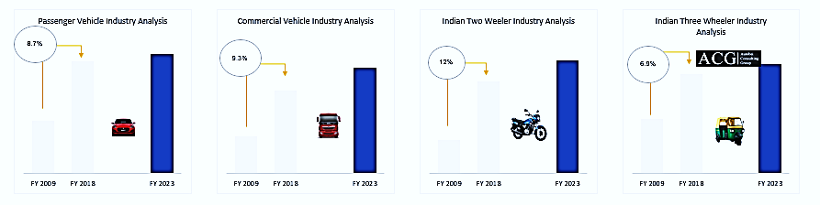

1. **KEY PLAYERS IN THE INDUSTRY:**

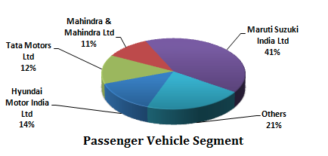 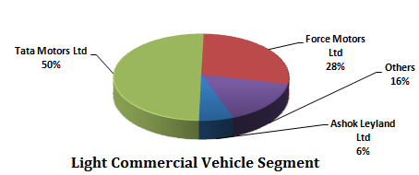

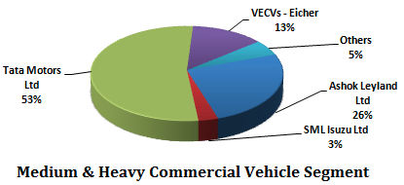

1. **PORTERS 5 FORCES ANALYSIS:**

1. **SWOT ANALYSIS:**

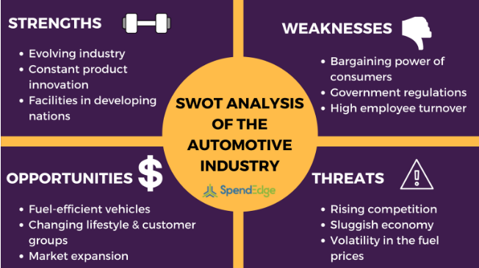

**VARIABLES USED FOR PERFORMING COMPANY ANALYSIS:**

1. **COMPANY OVERVIEW:**

* Tata Motors Limited, formerly Tata Engineering and Locomotive Company (TELCO), is an Indian multinational automotive manufacturing company headquartered in Mumbai, Maharashtra, India. It is a part of Tata Group, an Indian conglomerate. Its products include passenger cars, trucks, vans, coaches, buses, sports cars, construction equipment and military vehicles.
* Tata Motors' principal subsidiaries purchased the English premium car maker Jaguar Land Rover (the maker of Jaguar and Land Rover cars) and the South Korean commercial vehicle manufacturer Tata Daewoo. Tata Motors has a bus-manufacturing joint venture with Marcopolo S.A. (Tata Marcopolo), a construction-equipment manufacturing joint venture with Hitachi (Tata Hitachi Construction Machinery), and a joint venture with Fiat Chrysler which manufactures automotive components and Fiat Chrysler and Tata branded vehicles.

1. **BUSINESS MODEL:**

* Finance Capital- The funds and monetary resources needed to establish and operate the business. The business raises funds through a mix of debt and equity and optimizes its debt based on market conditions.

* Manufactured Capital - The production facilities and equipment for designing, prototyping and manufacturing vehicles.
  + - * + Tata Motors Works India: Jamshedpur, Pune, Lucknow, Pantnagar, Sanand, Dharwad
        + JLR Manufacturing Plants: Halewood (UK), Solihull (UK), Castle Bromwich (UK), Wolverhampton (Engine Manufacturing Center) (UK), Changshu (China), Rio de Janeiro (Brazil), Pune (Vehicle Assembly) (India).
* Intellectual Capital - R&D, innovation, design and engineering which form the basis of our product development efforts.

Cost on R&D = 2965.25 Cr

New Product Launched = Range Rover SV Coupe, Jaguar XEL, Magic Express, Tigor EV

* Human Capital - The collective skills, experience and expertise of our people, which drive our production process.

Employee Benefit Expense = 33243.87 Cr

TCS have become the largest private sector employer in India with highest retention rate.

* Social & Relationship Capital - Stable and sustainable relationships with value-chain partners and customers are indispensable for business continuity. Our relations with communities ensure Social License to Operate.

CSR Spend (TML) = 21.44 Cr

CSR Spend (JLR) = £10.5 Millions

4931 Sales and Service touchpoints for PV and CV businesses of TML.

1571 Strong dealer networks of JLR.

* Natural Capital - The automotive business is dependent on multiple natural resource based raw materials. At the same time, there are several impacts of the business activities on nature.

Energy Consumption Per Vehicle: TML = 4.91 GJ

JLR = 2.11 MwH

1. **SHAREHOLDING PATTERN:**

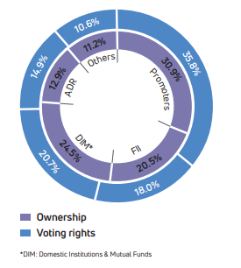

1. **GROWTH DRIVERS:**

* Strong industry know-how
* State-of-the-art manufacturing sites
* Consistent innovation
* Talent development and retention
* Disciplined capital allocation
* Robust risk management
* Strong supplier and customer relationships

1. **CAPITAL STRUCTURE:**

Authorized capital = 1000 Cr

Issued capital = 679.3 Cr

No. Of Shares = 3925851065

Face Value/Share = Rs. 2

Paid Up capital = 679.2 Cr

Debt (Long term + Short term) = 91123.93 Cr

1. **DIVIDEND HISTORY:**

The Company has maintained an average dividend yield of 0.98 % over the last 5 financial year.

1. **INTEREST COVERAGE RATIO:**

Tata Motor’s average interest coverage ratio over the last 5 financial years has been 7.55 times which indicates that the Company has been generating enough for the shareholders after servicing its debt obligations.

1. **DU-PONT ANALYSIS:**

|  |  |  |  |  |  |
| --- | --- | --- | --- | --- | --- |
| DuPont Analysis | 2015 | 2016 | 2017 | 2018 | 2019 |
| 24.86% | 13.65% | 10.44% | 9.47% | -47.32% |
| Asset Turnover | 1.105 | 1.027 | 1.005 | 0.894 | 0.993 |
| Interest Burden | 0.817 | 0.751 | 0.687 | 0.704 | 0.845 |
| Tax Burden | 0.644 | 0.788 | 0.651 | 0.815 | 0.916 |
| Equity Multiplier | 4.242 | 3.334 | 4.715 | 3.453 | 5.061 |
| Operating profit Margin | 10.07% | 6.73% | 4.92% | 5.34% | -12.18% |

DuPont Analysis (5 Factor Model) = (Sales/Asset) * (PBT/PBIT) * (PAT/PBT) * (Asset/Equity) * (PBIT/Sales)

**BIBLIOGRAPHY:**

1. <https://trak.in/tags/business/2019/08/08/automobile-crisis-3-5-lakh-indian-lose-their-jobs-tata-maruti-honda-mahindra-severely-impacted/>
2. <https://economictimes.indiatimes.com/jobs/indias-unemployment-rate-hit-6-1-in-2017-18/articleshow/69598640.cms?from=mdr>
3. <https://www.sanasecurities.com/tata-motors-equity-research/>
4. abridged-annual-report-2018-2019%20(1).pdf
5. <https://en.wikipedia.org/wiki/Automotive_industry_in_India>
6. <https://www.autobei.com/autoreports/automotive/indian-automobile-industry-analysis-fy-2018-and-outlook/>
7. <http://www.blog.sanasecurities.com/tata-motors-stock-analysis/>
8. [https://www.spendedge.com/blogs/swot-analysis-automobile-industry#](https://www.spendedge.com/blogs/swot-analysis-automobile-industry)
9. <https://investors.tatamotors.com/financials/72-ar-html/business-model.html>
10. <https://economictimes.indiatimes.com/tata-motors-ltd/capitalstructure/companyid-12934.cms>
11. <https://www.sanasecurities.com/tata-motors-equity-research/>